**Unity WebGL and Dedicated Web App Intercommunication:**

We have find **two** ways to send/receive information between a dedicated web app and WebGL

1. **API (Provide by the customer)**

The customer will provide an API where we will post data. Like in below image we are sending information of a cube (including its name, position) to a server (PHP web with mysql database) whenever user click to the cube. (Sample is attached Please check Web1 Folder + WebGLWSBuild).

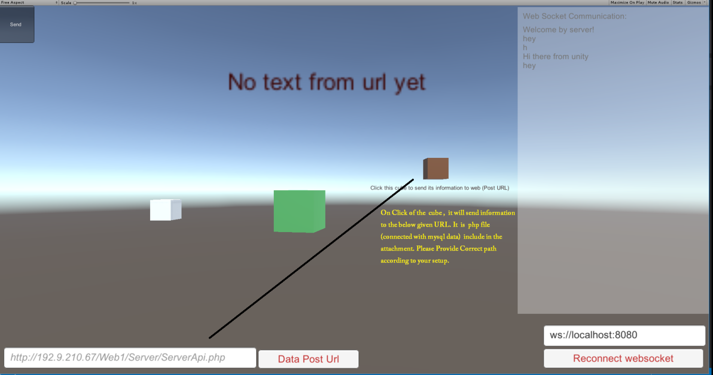

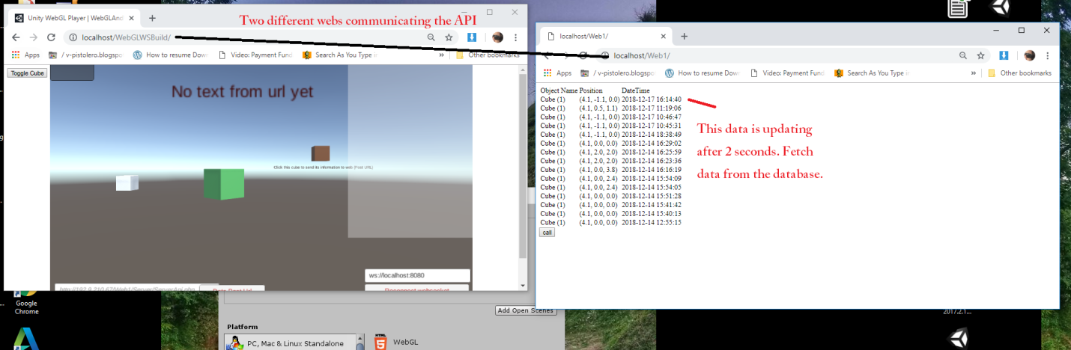

**Note**: In order to run above sample, please ensure

1. You have WAMP server installed
2. Placed **WebGLWSBuild** in WWW folder
3. Placed **Web1** in WWW Folder
4. Goto Mysql and create database with “objectinteractionweb1”.
5. Goto Web1 and find objectinteractionweb1.sql file and run it mysql.
6. Open WebGLWSBuild and Web1 in chrome separately.
7. **Web socket (Provide by the customer):**

In this way, a web socket server will be created where two way communications is possible instantaneously. (Sample is attached NodeJSWS folder+ WebGLWSBuild)

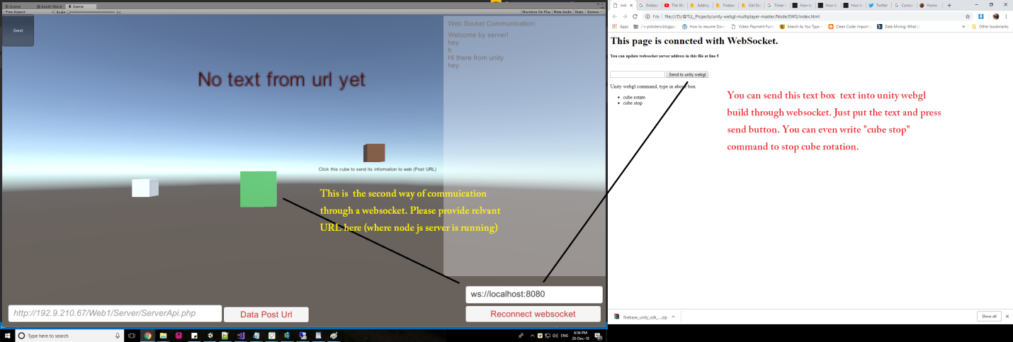

**Note**: In order to run above sample, please ensure

1. You have WAMP server installed
2. Placed **WebGLWSBuild** in WWW folder
3. Install nodeJS software
4. Goto **NodeJSWS** folder run the RunWebSocketServer.bat file
5. Goto **NodeJSWS** folder and open index.html file in chrome
6. Open WebGLWSBuild folder on chrome.
7. Start communication.

**Two Other ways:**

**UnityWebGL URL:**

You can pass some information to unity webgl through URL. But it only works at start of the web page loading and it is only one way.

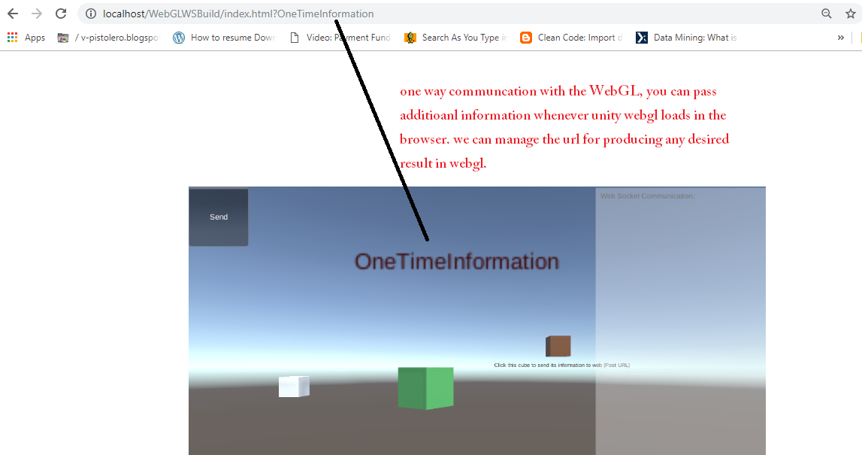

**Same Project:**

On the same webGL project we can call webGL functions from html/javascript.

